## 5.7 Directives and Injectables



This section will guide you to:

* Implement Angular directives

This guide has four subsections, namely:

5.7.1 Creating a directive

5.7.2 Declaring the directive

5.7.3 Adding the directive as a property

5.7.4 Pushing the code to Github repositories

**Step 5.7.1:** Creating a directive

* Change the color of the tag.

### 

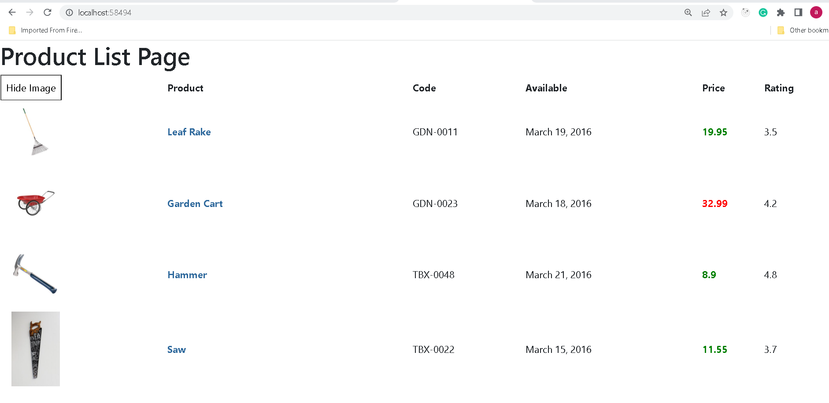

* To create the directive we need to run the command as ng generate directive ChangeColor in command prompt.

import { Directive } from '@angular/core';

@Directive({

  selector: '[appChangecolor]'

})

export *class* ChangecolorDirective {

*constructor*() { }

}

* Add the color property with the help of *ElementRef*.

/ import { Directive, ElementRef, Renderer2 } from '@angular/core';

@Directive({

  selector: '[appChangecolor]'

})

export *class* ChangecolorDirective {

*constructor*(*elem*: ElementRef, *renderer*: Renderer2) {

*renderer*.setStyle(*elem*.nativeElement, 'color', ”red”);

      }

}

**Step 5.7.2:** Declaring the directive

* Angular cli automatically added directive details in app.module.ts file.

import { NgModule } from '@angular/core';

import { BrowserModule } from '@angular/platform-browser';

import { AppRoutingModule } from './app-routing.module';

import { AppComponent } from './app.component';

import { ProductsComponents} from './products/products.component';

import { ChangecolorDirective } from './changecolor.directive';

@NgModule({

  declarations: [

    AppComponent,

    ProductsComponents,

    ChangecolorDirective

  ],

  imports: [

    BrowserModule,

    AppRoutingModule

  ],

  providers: [],

  bootstrap: [AppComponent]

})

export *class* AppModule { }

 ],

**Step 5.7.3:** Adding the directive as a property

* Add the created directive as a property for h1 tag

<div>

    <h1 appChangecolor> Product List Page </h1>

    <table class="table">

        <tr>

            <th><input type="button"  [value]="buttonValue" (click)="toggleImage()"/></th>

            <th>Product</th>

            <th>Code</th>

            <th>Available</th>

            <th>Price</th>

            <th>Rating</th>

        </tr>

        <tr *ngFor="*let* p of products">

            <td>

                <span *ngIf="showImage">

                <img

                    [src]='p.imageUrl'

                    [title]='p.productName'

                    [alt]='p.productName'

                    [style.width.px]='imageWidth'

                    [style.margin.px]='imageMargin'/>

                </span>

            </td>

            <td [style.color]="'#306A9D'" [style.font-weight]="700">

                {{ p.productName }}

            </td>

            <td>{{p.code}}</td>

            <td>{{p.available}}</td>

            <td [style.color]="p.price > 20 ? 'red': 'green'"

            [style.font-size.px]="16"  [style.font-weight]="700">

            {{ p.price}}

            </td>

            <td>{{p.rating}}</td>

        </tr>

    </table>

    <div>

    </div>

**Output:**

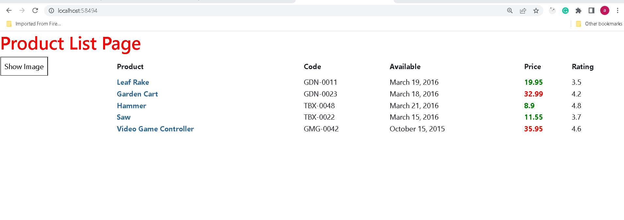

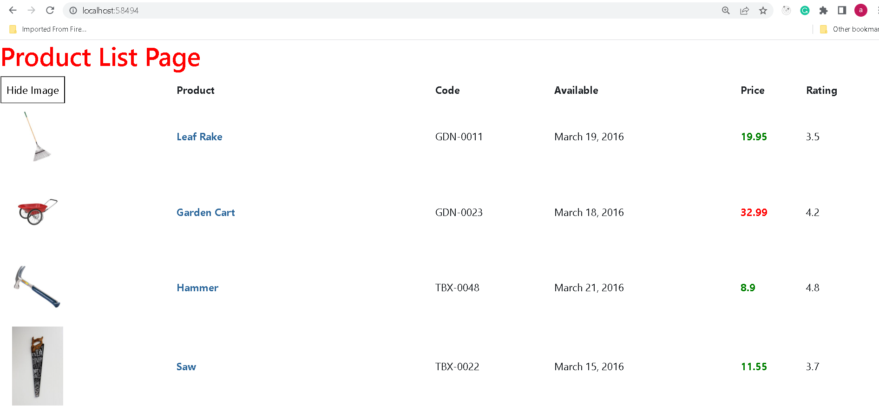

**Step 5.7.4:** Pushing the code to your GitHub repositories

Open your command prompt and navigate to the folder where you have created your files

cd <folder path>

Initialize your repository using the following command:

git init

Add all the files to your git repository using the following command:

git add .

Commit the changes using the following command:

git commit . -m “Changes have been committed.”

Push the files to the folder you initially created using the following command:

git push -u origin master